Fall 2013 MATH 160 Exam #1 Form B (chapters 1- 3) 200 points

Name:

Instructions: May use one 3x5 index card (back/front, typed/written) and calculator.
(Round answers according to the rules talked about during lecture)

Lisa has been looking to move into a furnished two-bedroom apartment in La Mesa. After selecting a random sample of 10 apartment units, she came up with a list of what two-bedroom apartments are renting for.

$1300, $1290, $930, $1500, $1000, $2599, $950, $500, $1200, $1290

- Find the 5-number summary of two-bedroom rentals in La Mesa.

- Calculate the IQR of two-bedroom rentals in La Mesa.

- Using the 1.5 * IQR rule, are there any outliers? What are they? This is not just your opinion; you need to back up your answer with work.

- True/False Circle your choice.

a) The Empirical Rule can be applied to data with ANY distribution. True/False
b) The age of students in this class is discrete data. True/False
c) It doesn’t matter how a sample is collected as long as you have a very large sample. True/False
d) Asking people to call in to voice their opinion about an issue is NOT a valid way of collecting a random sample which is representative of the population. True/False
e) A parameter is a measurement that comes from the population. True/False
f) A statistic is a measurement that comes from a sample. True/False

- The mean length of one-year-old spotted flounder, in millimeters, is 126 with standard deviation of 18. The mean length of two-year-old spotted flounder is 162 with a standard deviation of 28. The distribution of flounder lengths is approximately bell-shaped. Mark caught a one-year-old flounder that was 150 millimeters in length and a two-year-old flounder that was 190 millimeters in length.

- Find the z-score for the one-year-old flounder that was 190 millimeters in length.

- Find the z-score for the two-year-old flounder that was 200 millimeters in length.

- Which fish is longer, relative to fish the same age? Circle your choice.

one-year-old flounder / two-year-old flounder

- Is either fish an unusual length? You must explain why.

- Using the empirical rule, approximate the percentage of one-year-old flounders that are between 108 millimeters and 144 millimeters in length. Assume the distribution of flounder lengths is approximately bell-shaped. The mean length of one-year-old spotted flounder, in millimeters, is 126 with standard deviation of 18.

- This histogram displays hours of sleep per day for a random sample of 200 subjects.

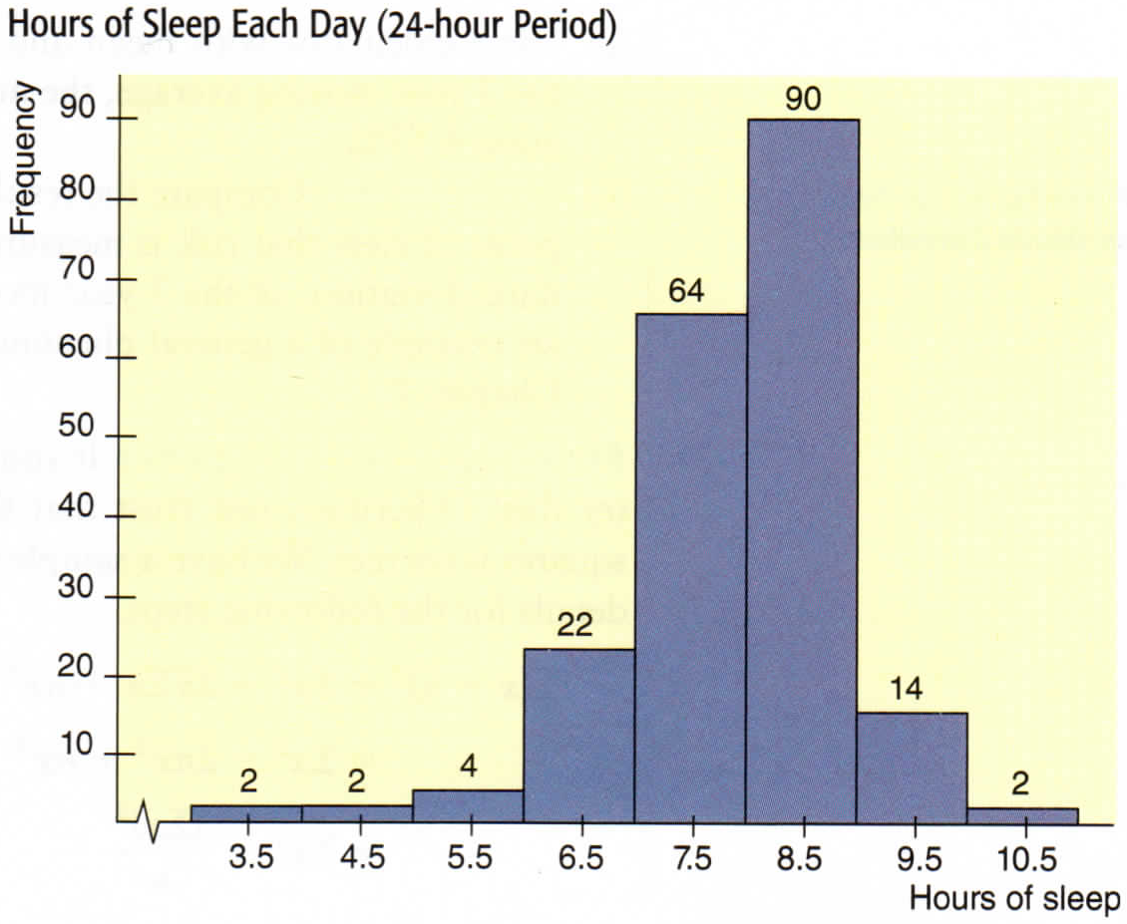
a) Find the mean hours of sleep.

b) What percentage of people had less than 9 hours of sleep?

- Below are two box plots for the number of cell phone contacts stored on phones owned by men and women.

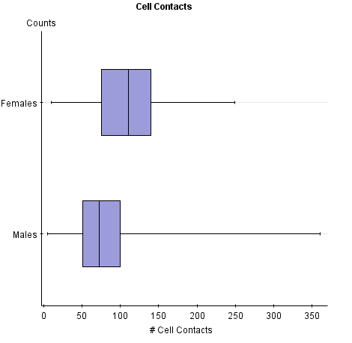
a) What percentage of males have between 50 and 100 contacts on their cell phone?

b) What percentage of females have less than 75 contacts on their cell phone?

c) For males is having 350 contacts and outlier? Explain.

Calculate the IQR for the calories in each brand of ice cream.

Dryers Ice Cream (D calories)
IQR =

Corner Stone ( CS calories)
IQR =

Ben & Jerry’s ( BJ calories)
IQR =

Which brand has the least variable calories in their ice cream?

Which brand has the lowest median calories in their ice cream?
- Boxplot of calories in ice cream by brands.

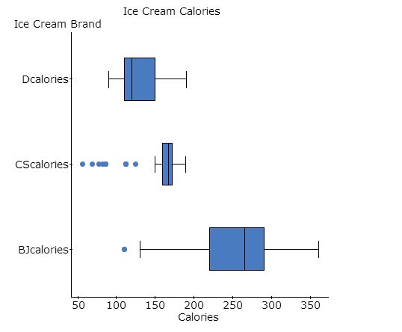

The given frequency distribution lists the one-way commuting distances of workers in San Diego for the month of January.
Distances in miles | Frequency | Class Midpoints
1 - 8 | 2
9 - 16 | 8
17 - 24 | 20
25 - 32 | 12
33 - 40 | 8
41 - 48 | 1

- Complete the table by finding the class midpoints.

- Find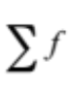 (give the numerical answer)

- What is the class width?

- Find the mean number of miles driven in the month of January.

- Find the standard deviation for the number of miles driven in the month of January.

- Find the variance for the number of miles driven in the month of January.

- The mean of electrical energy consumption amounts for a home during a two-month period is 2767 kWh, and the standard deviation is 472 kWh.

  - find the minimum “usual” value

  - find the maximum “usual” value

  - For one particular two-month period, the power company recorded consumption of
3700 kWh. Is that amount unusual? Explain.

